VIEW MANAGEMENT BLOG
Model Agency in Barcelona and Madrid

VIEW MANAGEMENT ABOUT US FACEBOOK INSTAGRAM TWITTER

FABIO MANCINI FOR PHILIPP PLEIN PRE-FALL 2018 BY DANIELE ROSSI
Campaign

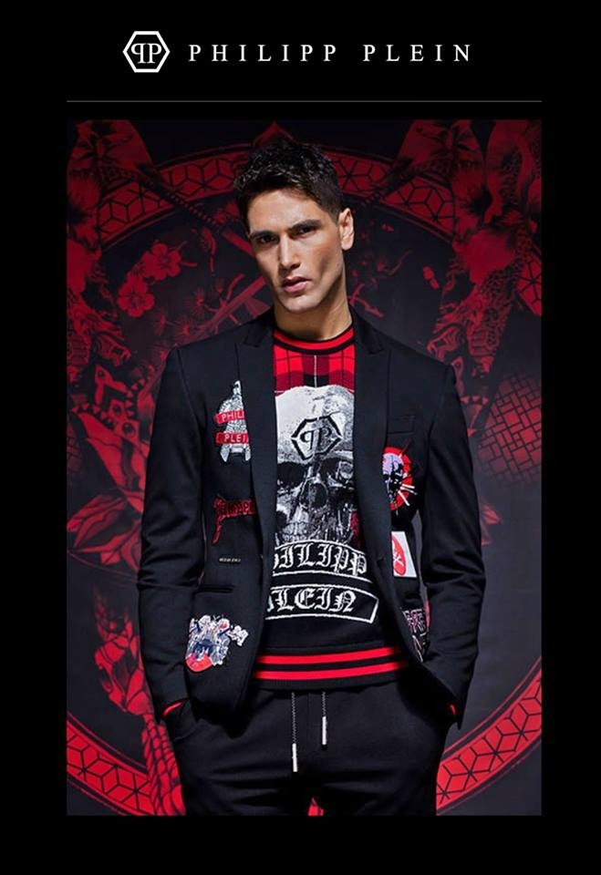
Fabio Mancini wears Philipp Plein‘s skull and samurai-infused Collection for Pre-Fall 2018. Photographed by Daniele Rossi, grooming by Salvatore Distasio and Paola D’Avenia

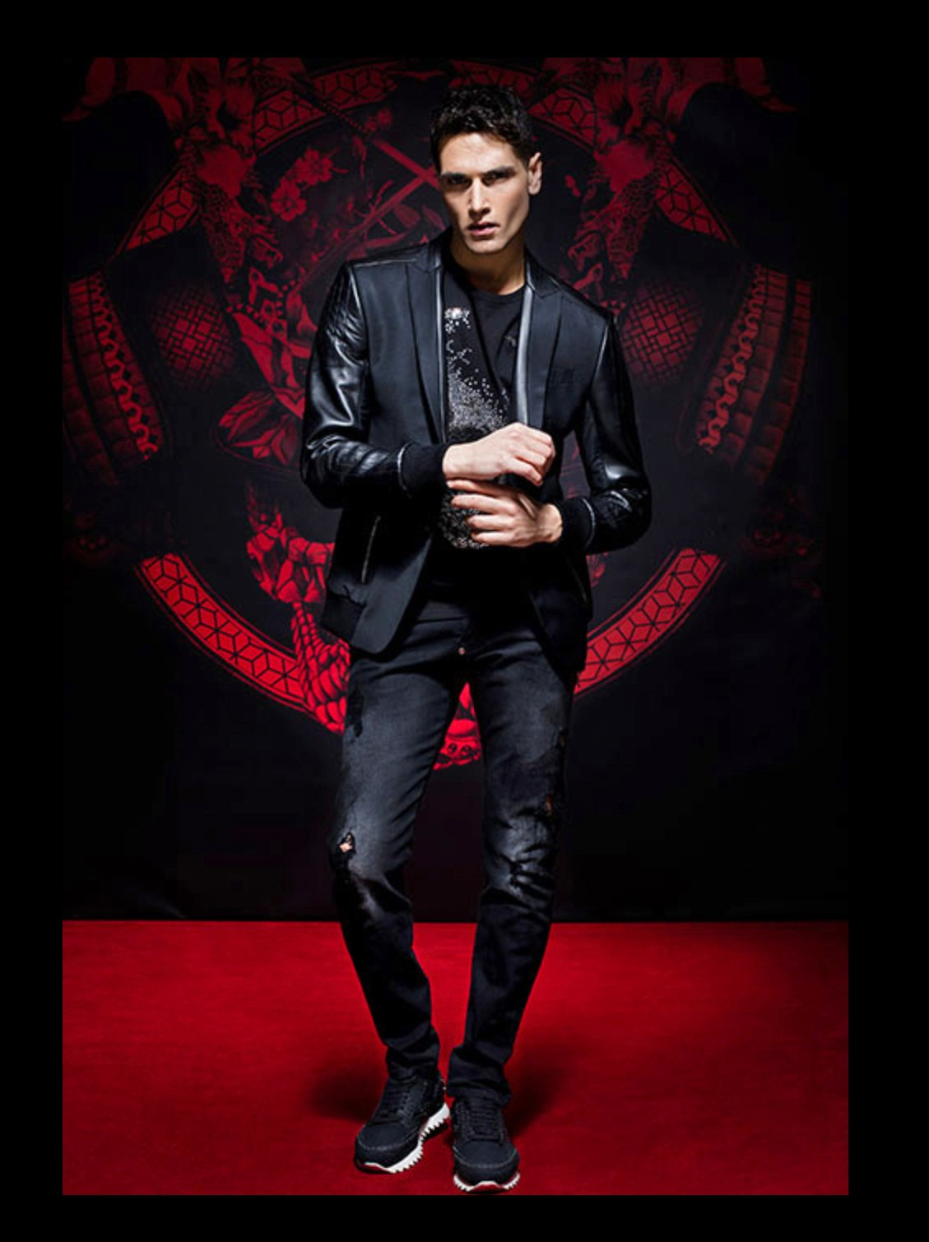
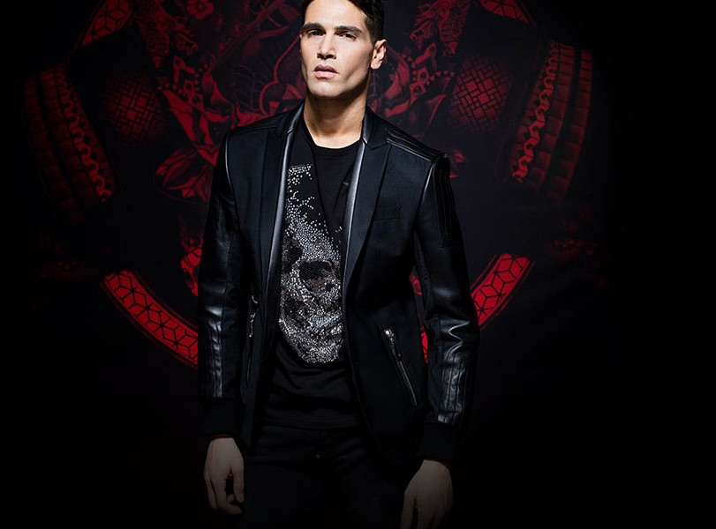
25 May, 2017 · viewmanagement · Tagged Daniele Rossi, Fabio Mancini, Philipp Plein · Leave a comment

